1. **Create a script “myscript” and perform following?**
2. To create directory named subdir in current directory à mkdir subd1 in myscript.sh

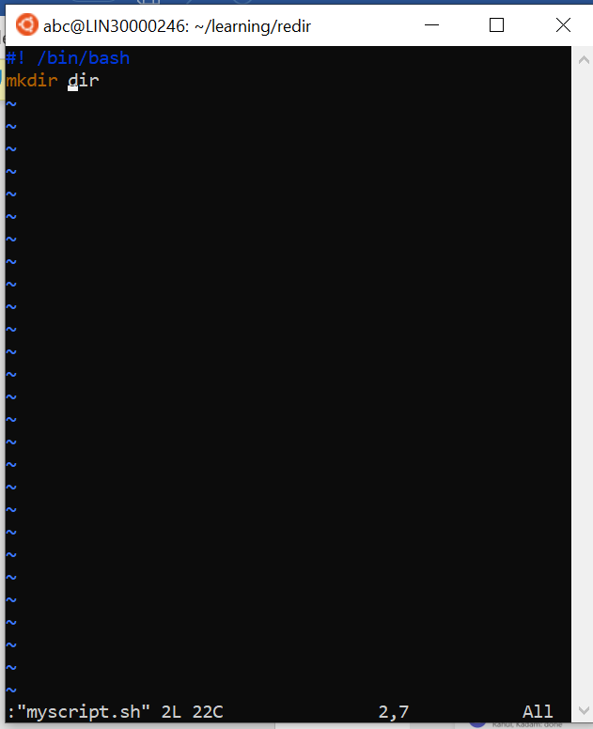

1. To create a file dircontent with contents of current directory à ls -l ./ > dircontent

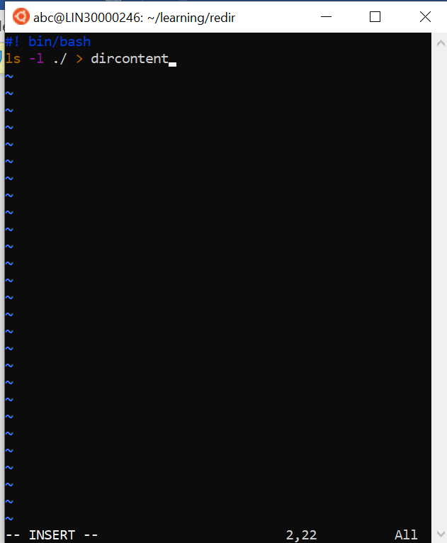

1. To display the contents of dircontent file à cat dircontent in bash file

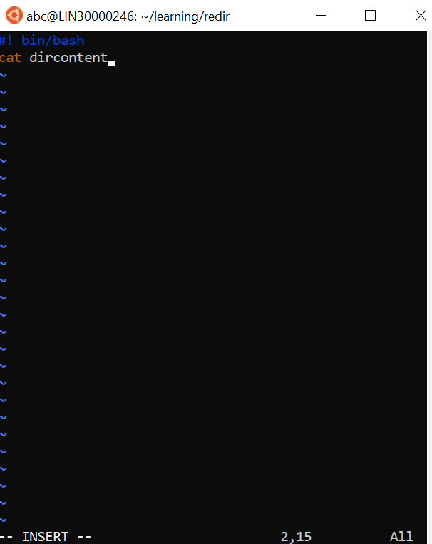

1. To display contents of a unknown file à cat unknownfile in script file

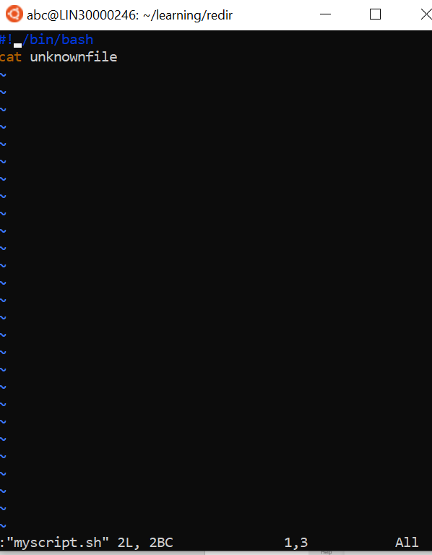

**Q2. Run a script and validate the output**

1. Redirect stdout to an o/p file stdout.txt

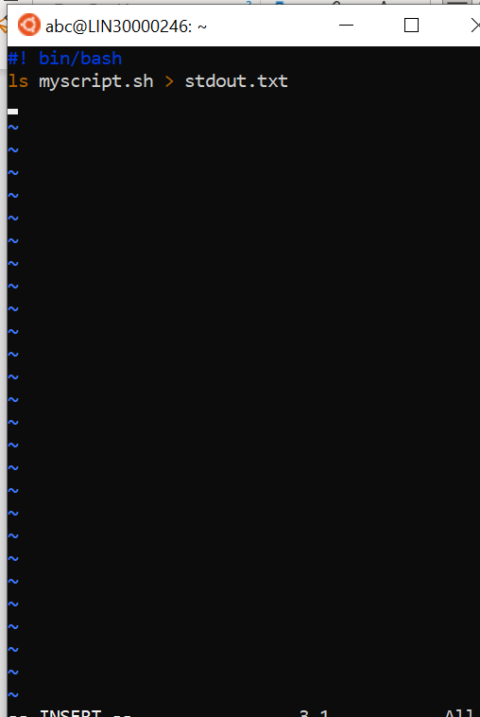

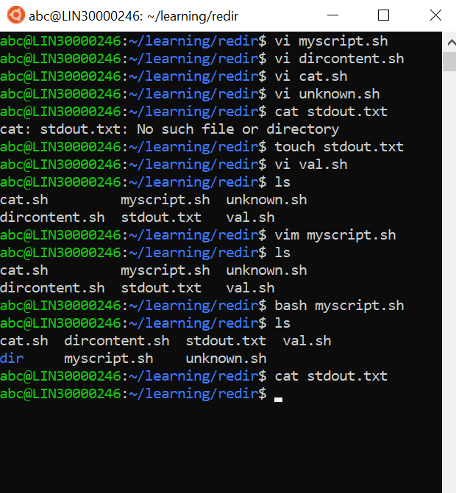

1. Redirect stderr to o/p file named stderr.txt

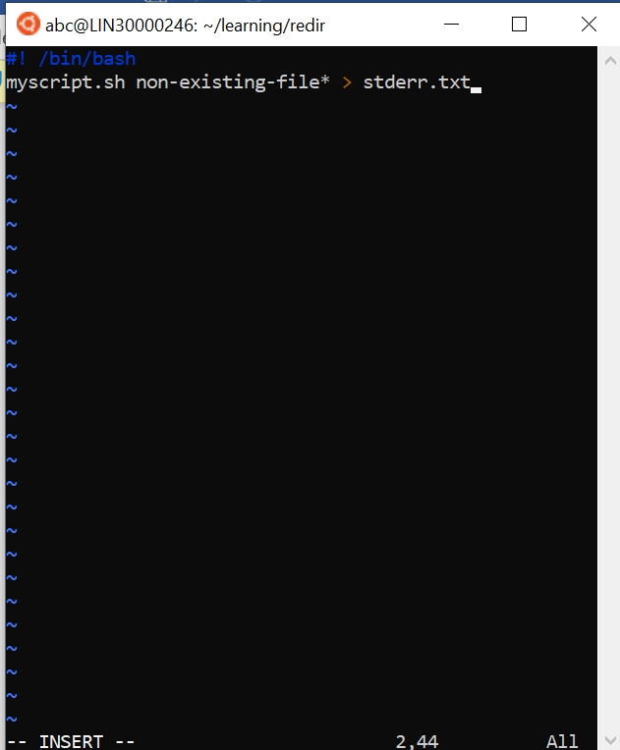

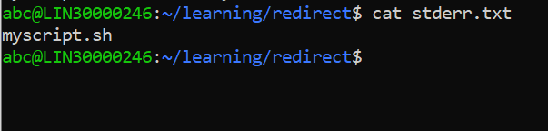

1. Redirect both stderr / stdout to o/p file named stdall.txt

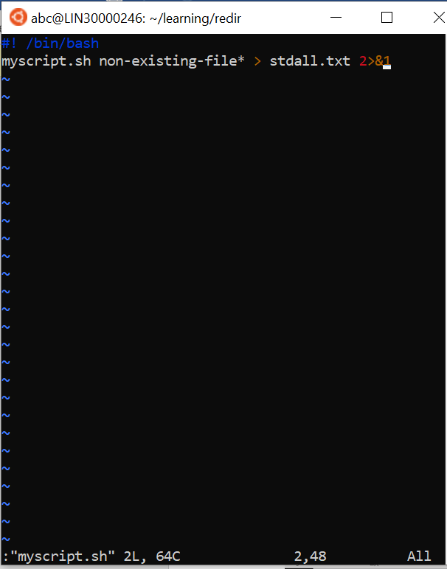

1. Display all o/p and errors and redirect both stdout/stderr to o/p file stdall.txt

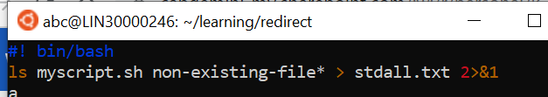

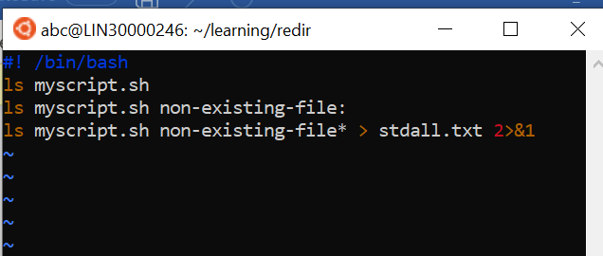

**Q3. Run a script and validate the output**

